Getting started with .Net Core 5.0

Lynda.com course: First look at .Net 5

https://www.linkedin.com/learning/first-look-dot-net-5/dot-net-frameworks-versions-and-names?u=2109516

Releases: .Net Framework 2002

.Net Core 2016

**.Net 2020 (rebranding of .Net Core)**

Evolvement of .Net

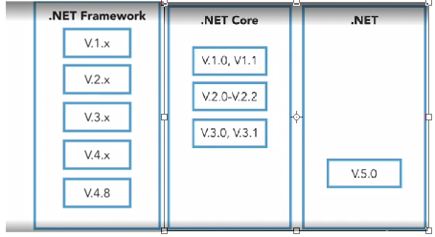

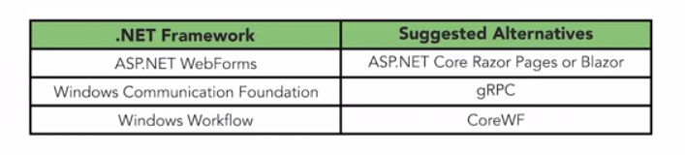

To compile and run you need a) an essential SDK and b) set of runtime engines

Decoupled from Windows 10

Install

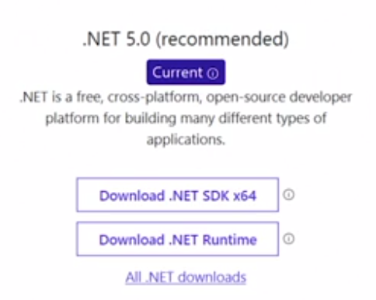

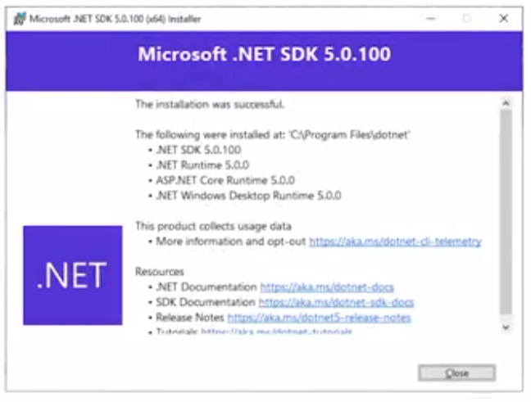

Some of the libraries installed for you (build tools, testing tools, and NuGet package tools)

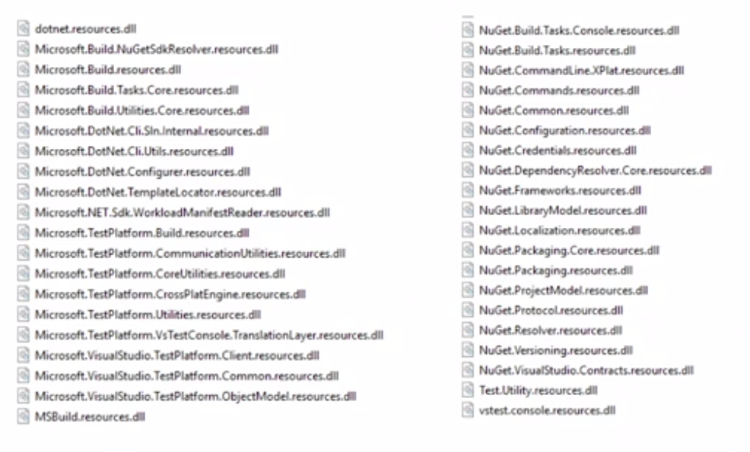



If you have the latest Visual Studio installer it has the SDK and will install it.

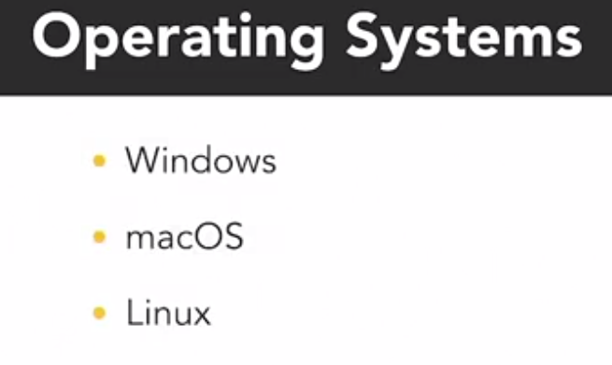

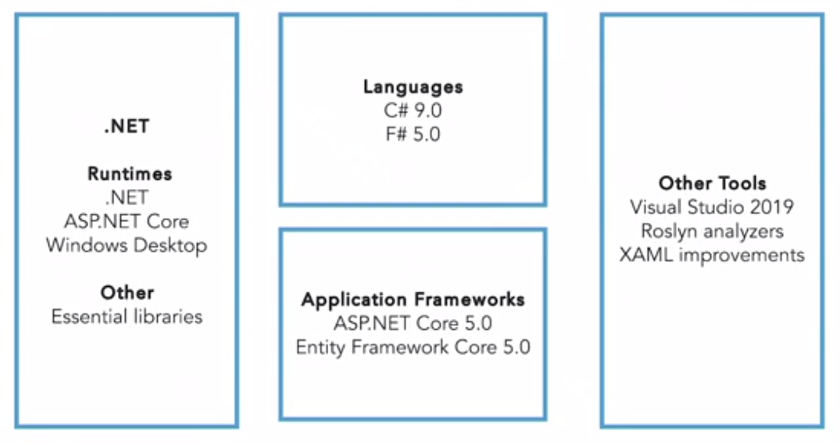

C# 9.0 new Features

Readonly class

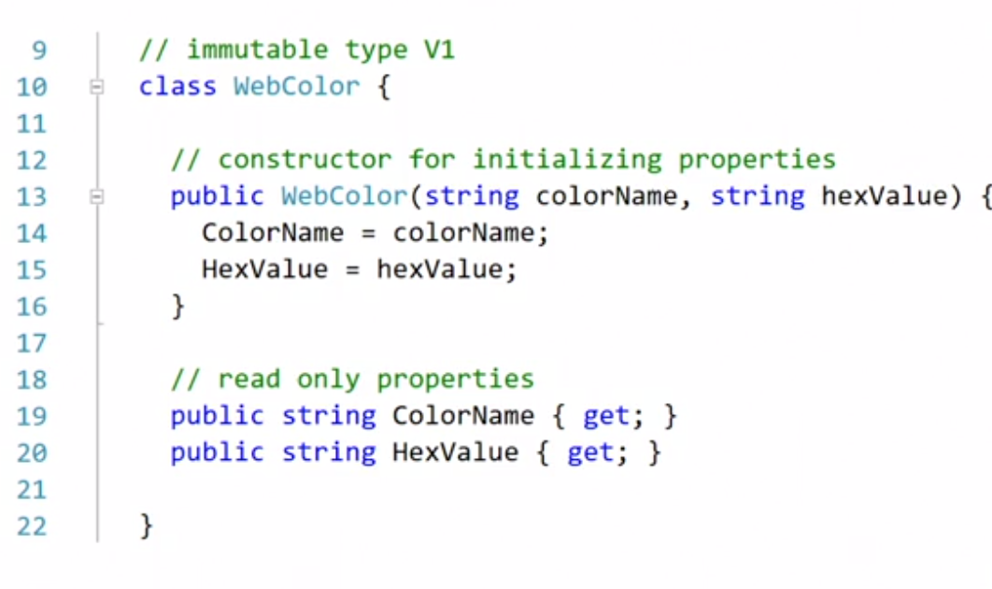

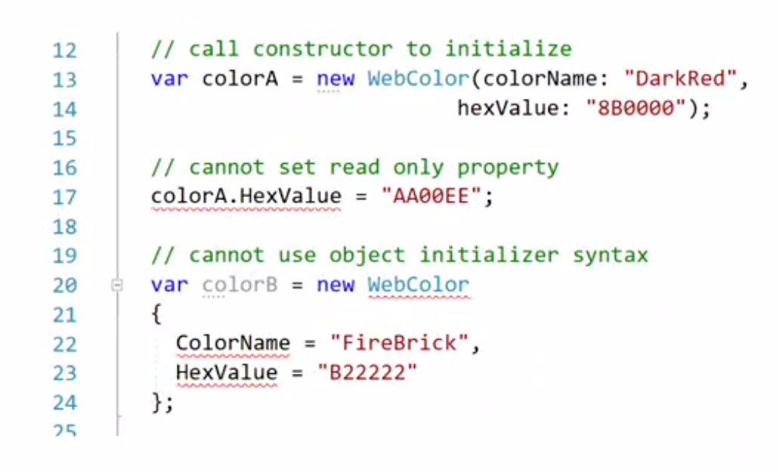

Using the init properties

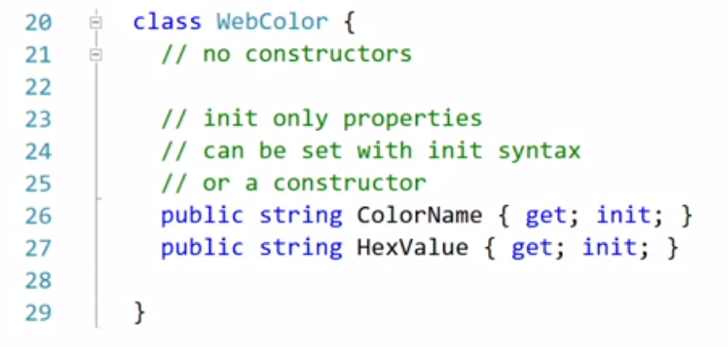

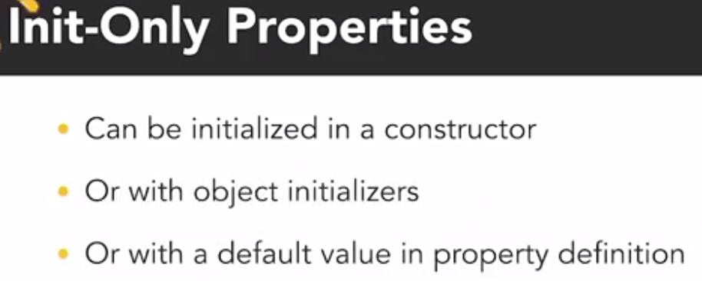

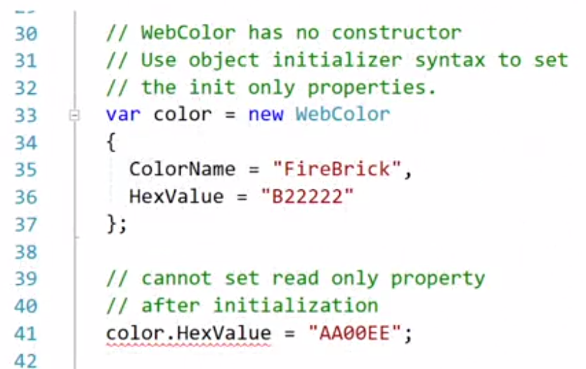

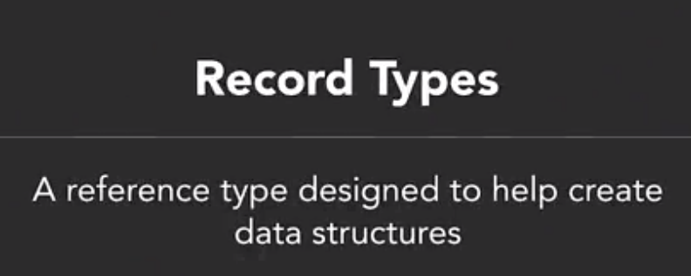







Make a class immutable (changes are controlled in a safe manner)

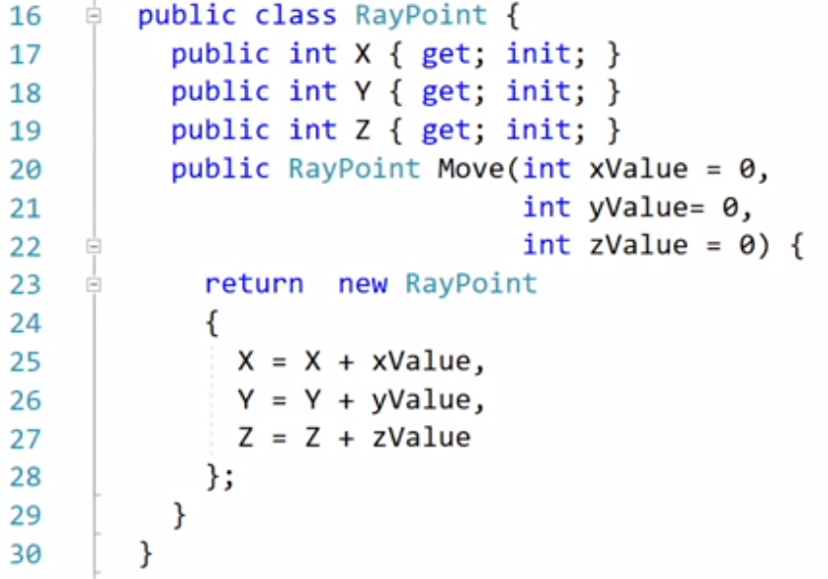

This class has a Move method that returns a **new instance of the class.** Therefore, the original instance is **NOT** affected. The following demonstrates a) create an immutable type (pointA), b) create another point based on pointA (pointB) or c) use the Move() to create a new instance.

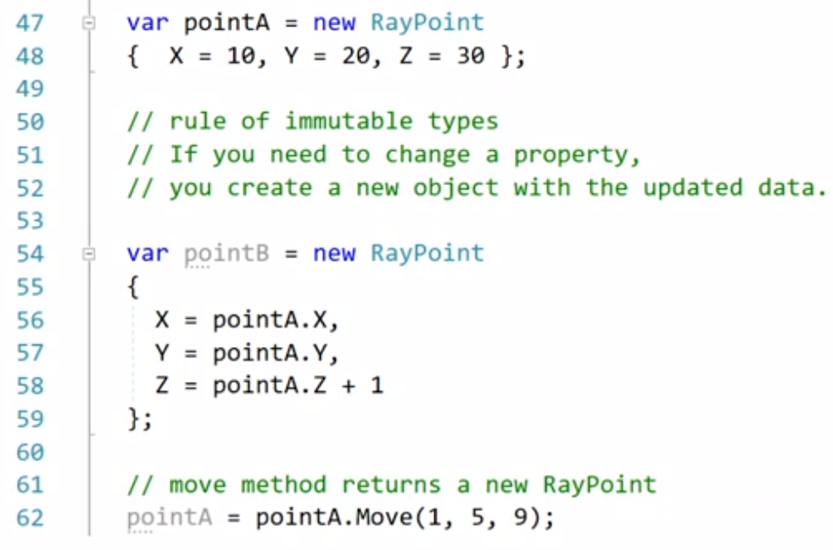

Using Record types

Can be declared like a class

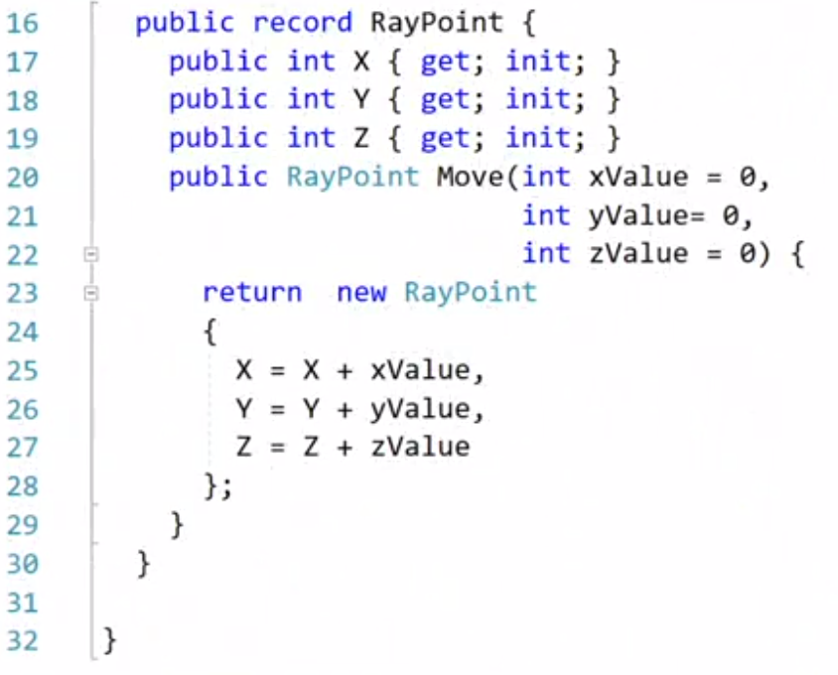

However, this syntax is much simpler (each init becomes an init property)

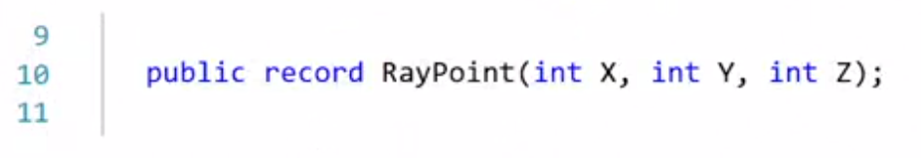

Using records

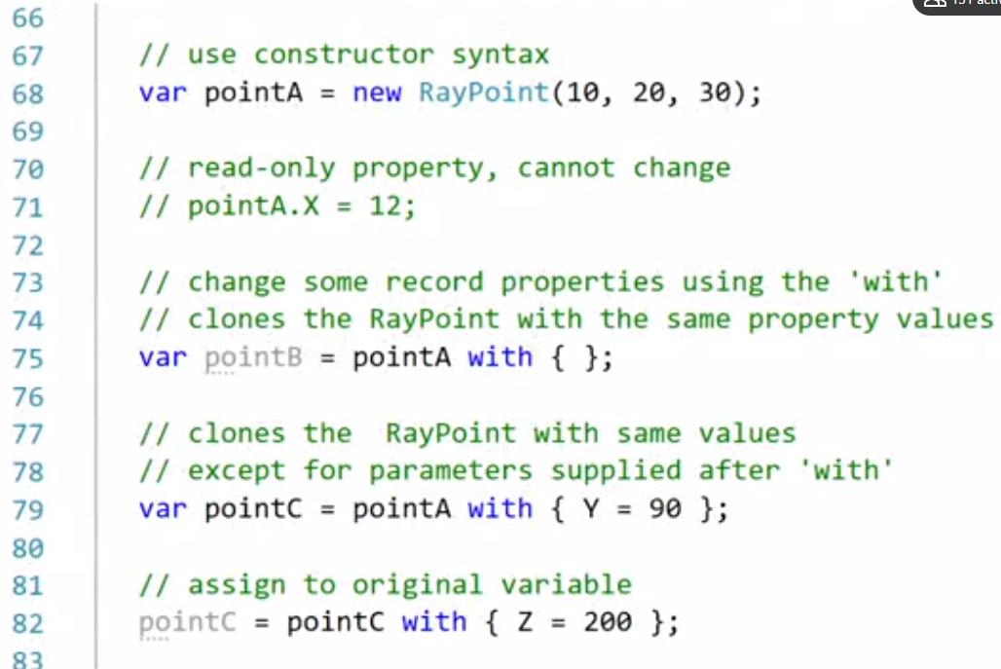

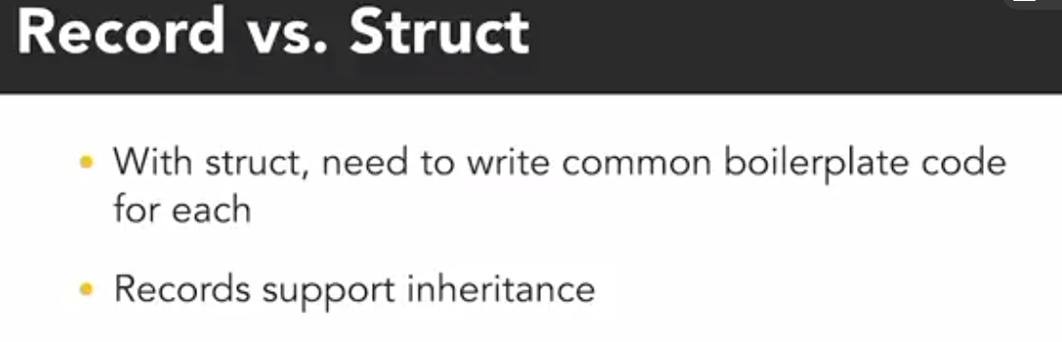





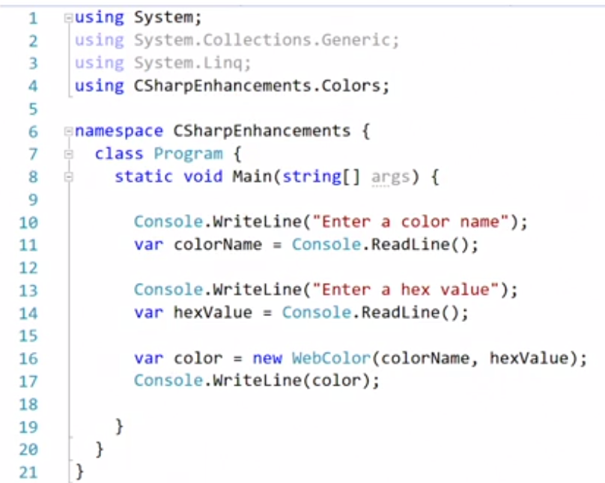 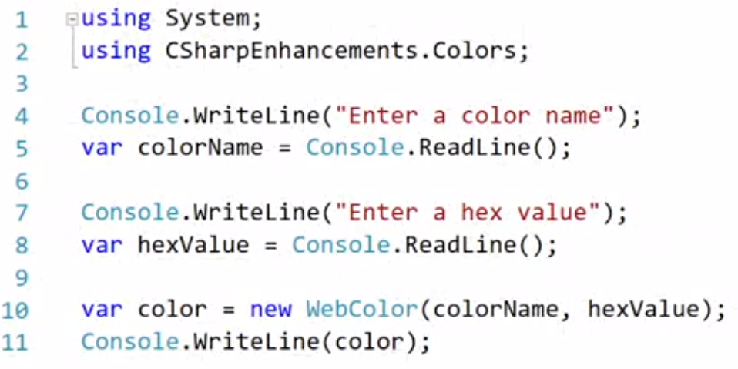



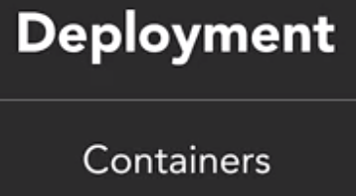













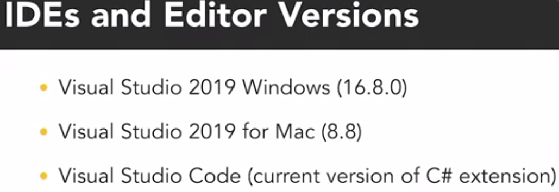



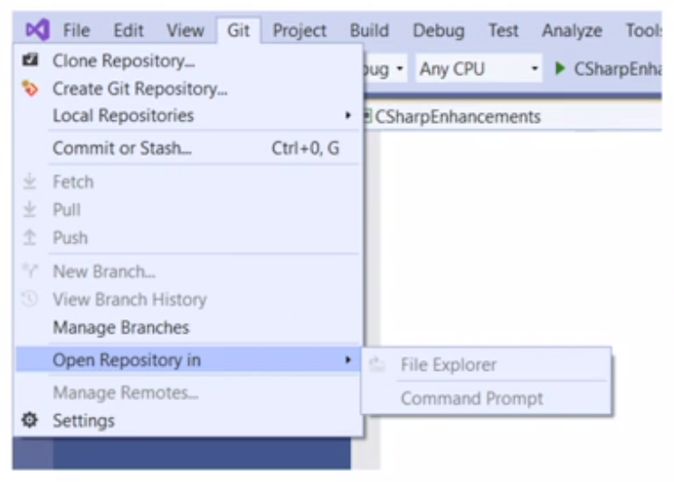





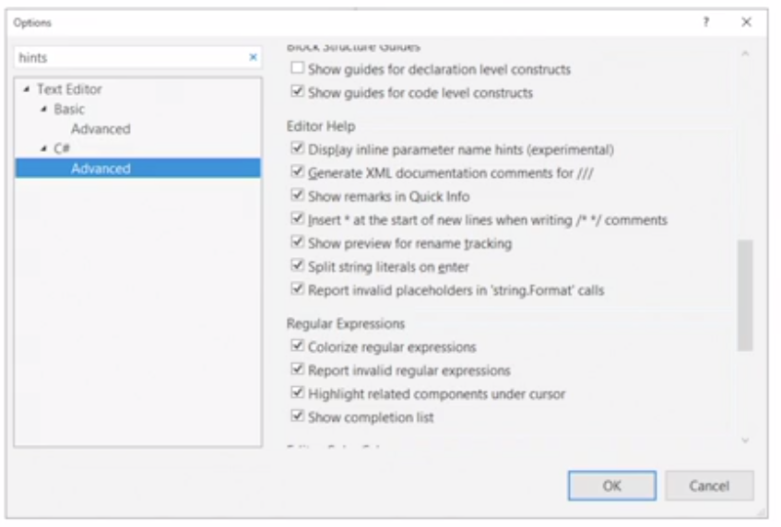

What hint does, adds parameter box hints to editor

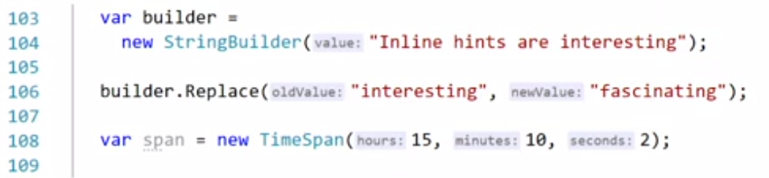

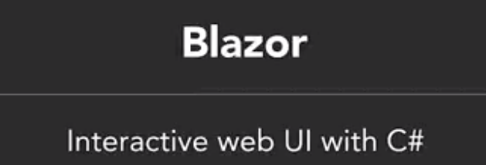

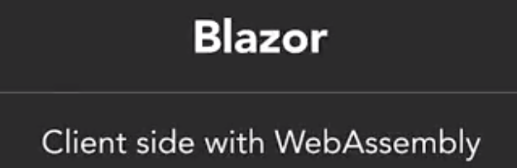 

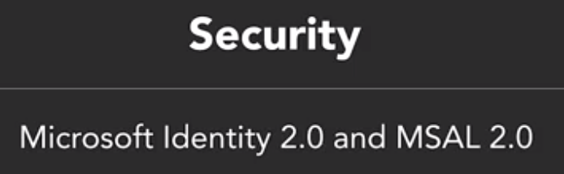









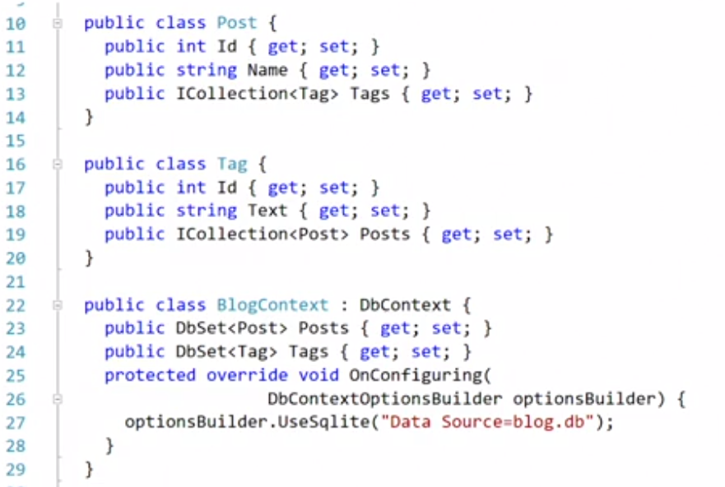

Custom savepoints within a transaction

